Eggplant Kebab

First peel 6 eggplant and slice them . After that soak them in salt water. Slice 4 pepper and 3 tomatoes too. Put 1kg mince in a large bowl. Add 1 onions juice and a pinch of salt, pepper and red pepper. Knead the mince until everything mixes. Drain eggplants. Take a slice of eggplant,pepper and tomato, make a small meatball and put them side by side in a oven tray. Bake it for 1 hour. Enjoy your meal.

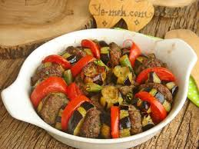

|  |  |
| --- | --- |
| Ingredients | kcal |
| 6 eggplant(1kg) | 249 |
| 4 pepper(200g) | 80 |
| 3 tomato(300g) | 54 |
| Mince(1kg)  Total eveything | 2020  2403 |

|  |  |  |  |
| --- | --- | --- | --- |
| Name | Weight | Height | Index |
| Salih | 70 | 1.71 | 23.94 (normal) |
| Seydi | 85 | 1.71 | 29.07 (overweight) |
| Perihan | 80 | 1.70 | 27.68 (overweight) |
| Mustafa | 81 | 1.78 | 25.56 (overweight) |
| İbrahim | 80 | 1.83 | 23.89 (normal) |
| Büşra | 50 | 1.60 | 19.53 (normal) |
| Yusuf | 55 | 1.85 | 16.07 (thin) |